Symmetry- Answers

Key Stage 2: 2003 Paper A
1.
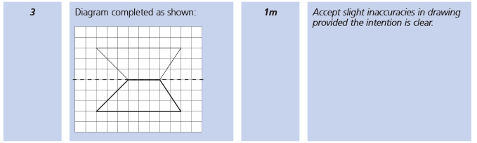
Key Stage 2: 2003 Paper A
2.
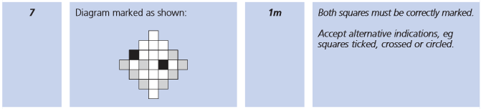
Key Stage 2: 2003 Paper B
1.
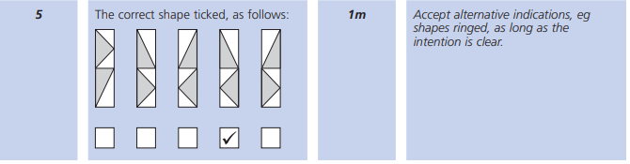

Key Stage 2: 2004 Paper A
2.
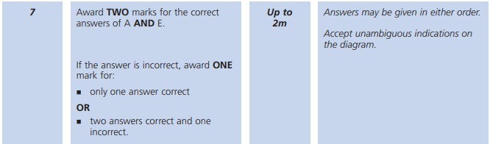
Key Stage 2: 2004 Paper B
1.
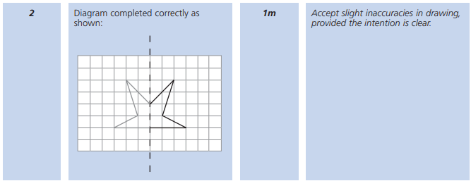
Key Stage 2: 2005 Paper A
1.
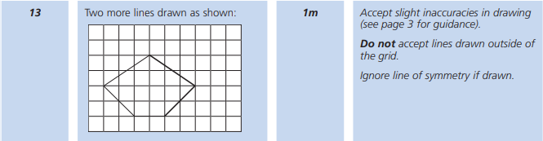

Key Stage 2: 2006 Paper A
1.
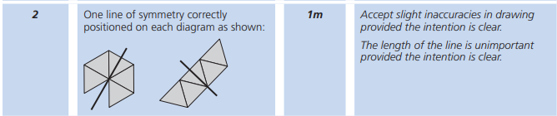
Key Stage 2: 2007 Paper A
1.
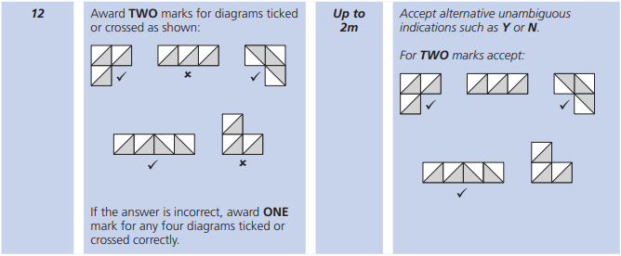
Key Stage 2: 2008 Paper B
1.
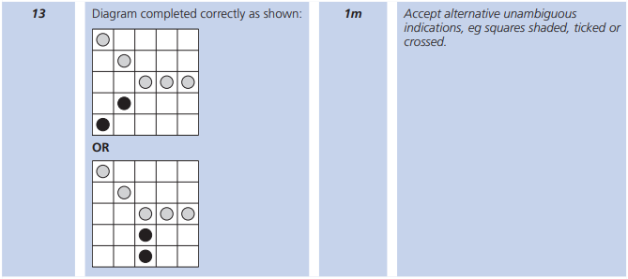

Key Stage 2: 2009 Paper B
1.
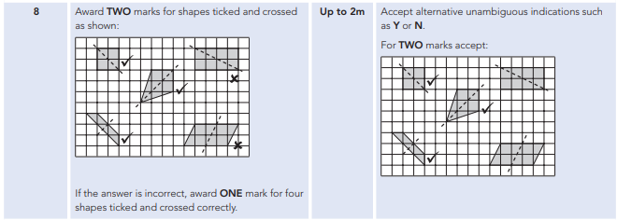
Key Stage 2: 2010 Paper A
1.
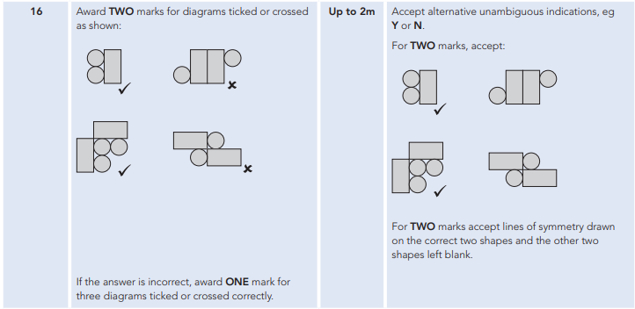

Key Stage 2: 2011 Paper A
1.
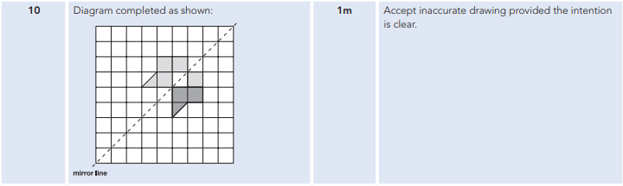
Key Stage 2: 2011 Paper B
1.
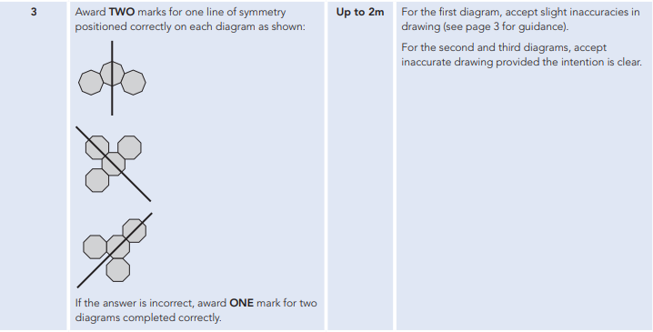
Key Stage 2: 2012 Paper A
1.

Key Stage 2: 2012 Paper B
1.
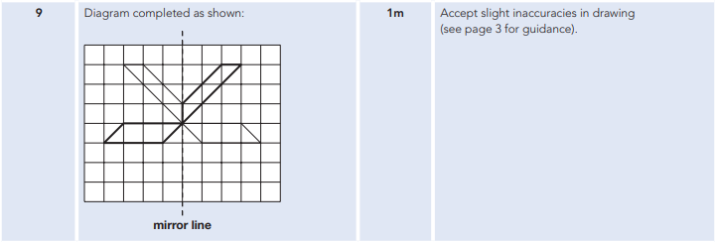
Key Stage 2: 2013 Paper A
1.
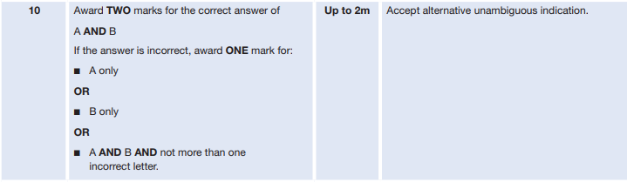
Key Stage 2: 2015 Paper A
1.
